Open azure board ex <https://dev.azure.com/swasthikbsthr/>

Reference : https://github.com/BakkappaN/PlaywrightAzureDevopsPipeline

Click on new project, Enter details and save

Open created project, click on repo above select new or importas your wish

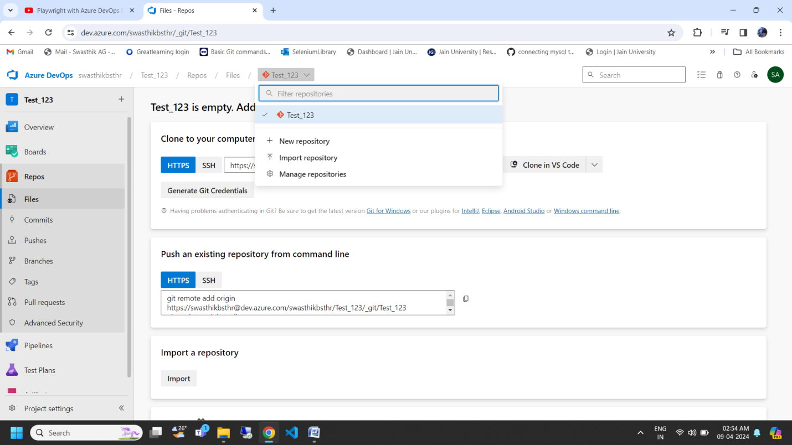

Click on clone

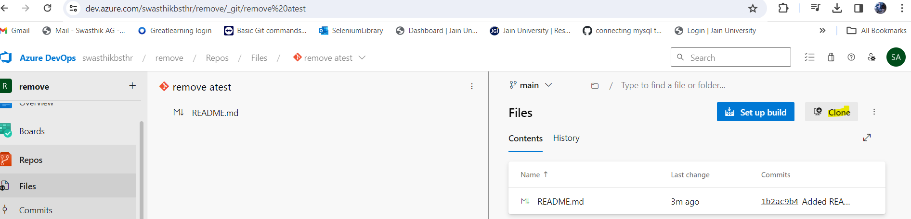

Install azure repo extension

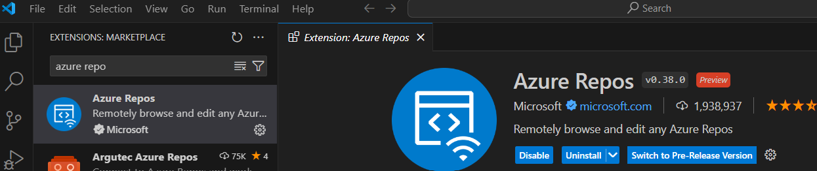

Select clone repo, enter the url which you created the repo in the above step and chose the folder where you want to save it.

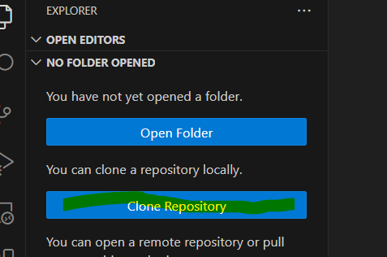

Open the clone the repo

Then you start installing the your playwright

Note : Install playwright allure report using below command

npm install --save-dev allure-commandline

npm install --save-dev allure-playwright

In playwright configuration file just add below line

reporter: [['html'],['allure-playwright']],

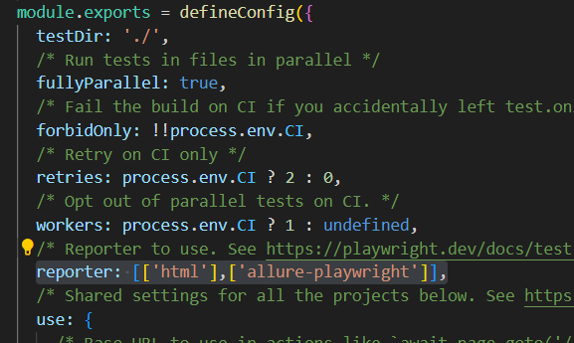

npx playwright install chromium

npx playwright install msedge

Run your testcases, once completed then enter below command

npx allure serve allure-results

once allure report done

then you can start merging your code

**----------------------------------Pipeline Creation---------------------------------------------------**

**Note :** for personal access approve wil take minimum 3 days

Install below extension

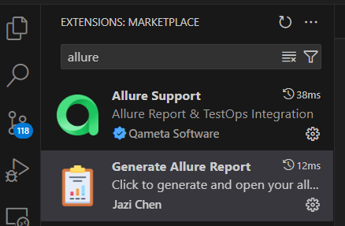

Click on source control from VS code

Click on commit and push always give a message

Now got devops and check your repo all changes should reflect

Click on pipeline

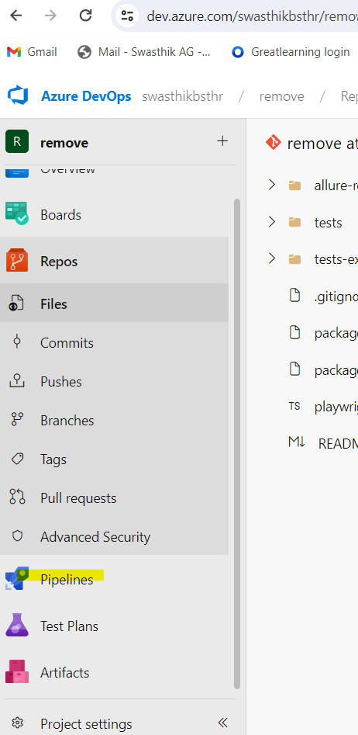

Click on create pipeline and select azure repo git

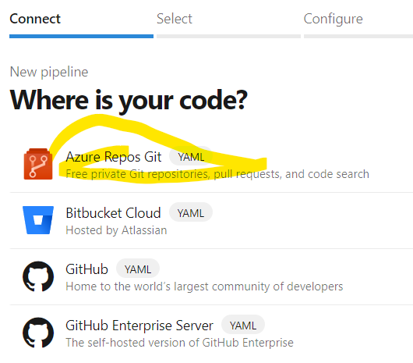

Click on the project name which is displayed and select starter pipline

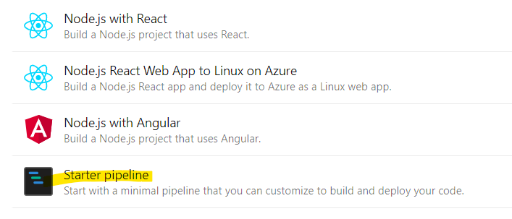

Remove all the code from yaml just copy paste below code

trigger:

- main

pool:

vmImage: ubuntu-latest

steps:

- task: NodeTool@0

inputs:

versionSpec: '18'

displayName: 'Install Node.js'

- script: npm ci

displayName: 'npm ci'

- script: npx playwright install --with-deps

displayName: 'Install Playwright browsers'

- script: npx playwright test

displayName: 'Run Playwright tests'

env:

CI: 'true'

- task: PublishPipelineArtifact@1

inputs:

targetPath: playwright-report

artifact: playwright-report

publishLocation: 'pipeline'

condition: succeededOrFailed()

- task: PublishAllureReport@1

displayName: "publish allure report"

inputs:

testResultsDir: "allure-results"

reportName: "Report 1"